Explore Graph
This Graph is an example to test the ideas of exploring the path.
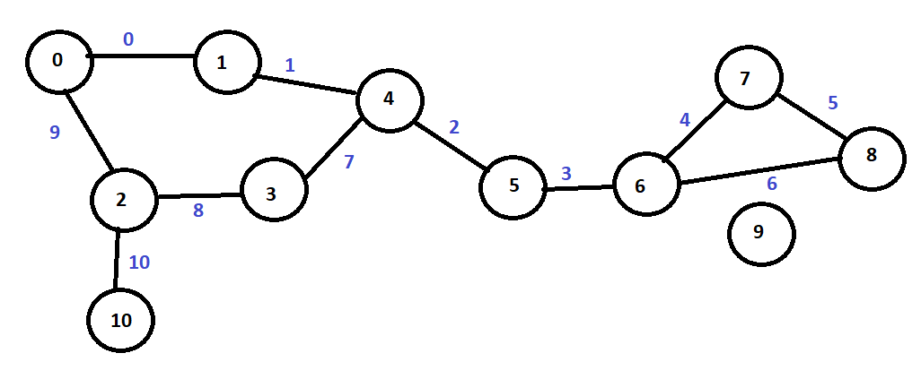
Figure 1The graph to search

Test 1 start_v=0 end_v=9
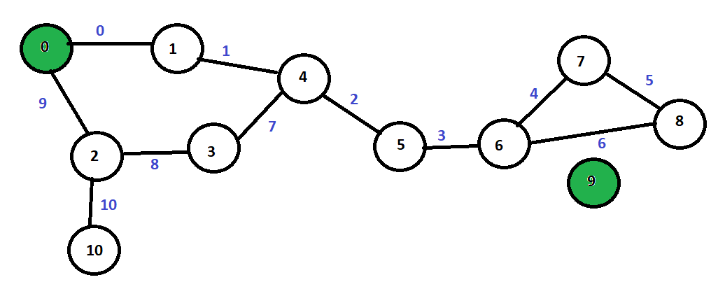
Figure 2Find path to Vertex with degree 0
Vertex 9 has a degree of 0 this means that there is no path so no need to explore anything.

Test 2 start_v=0 end_v=10
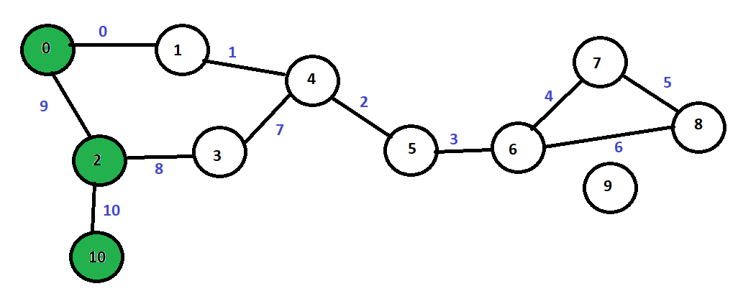
Figure 3Shortest Path to a Vertex

Short Path=V={0,2,10} E{9,10}
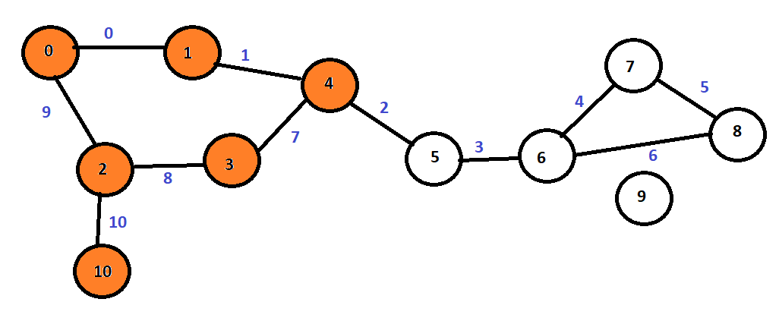
Figure 4Medium Path to Vertex
Medium Path=V={0,1,4,3,2,10} E={0,1,7,8,10}

Long Path=v={0,1,4,5,6,7,8,7,6,5,4,3,2,10} e={0,1,2,3,4,5,5,4,3,2,7,8,10}
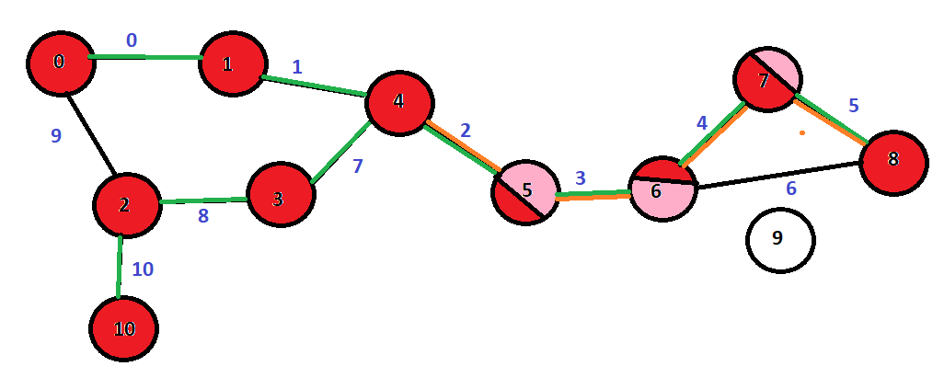
Figure 5 Longest Path to Vertex

Shortcuts
First don't cross bridge paths unless you must cross it.
In this example crossing the path is worst thing to do.
If you find a duplicate V then go back to the start_v=0 then find non duplicated vertices.
Check to level X both the start_v and end_v
In the above example if X = 3 then
the vertices 3 from 0 are in any direction are
Path 1 V={0,1,4} Path 2 V={0,2,10}
the vertices 3 from 10 are in any direction are
Path 1 V={10,2,3} Path 2 V={10,2,0}

Is there a relationship between Diameter/radios and the average path length? If there is we have to know the diameter and radius first. Maybe get diameter and radius when constructing the graph.

If a Vertex has a degree of 1 then finding a path to the vertex connected to it is to find a path to it.
In the case of V10 all paths go through V2.

Test 3 start_v=5 end_v=1
Longest Path V={5,6,7,8,8,7,6,5,4,3,2,10,10,2,0,1} E={3,4,5,5,4,3}
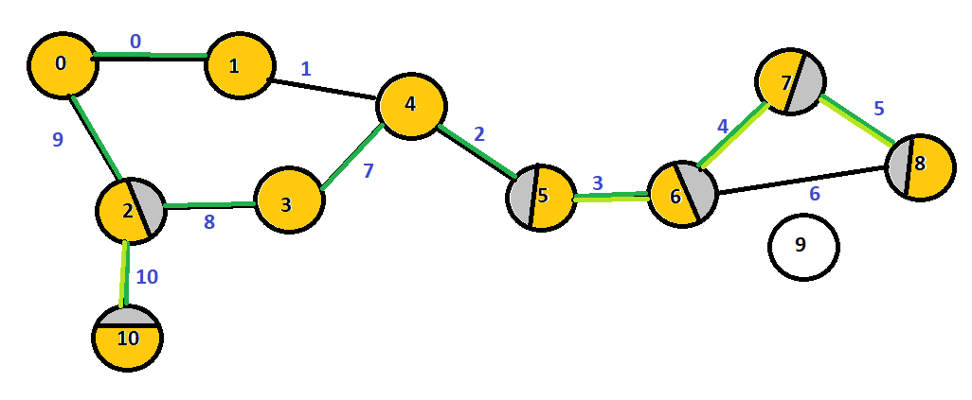
If you find a duplicate V then go back to start_v=5 then find non duplicated vertices IF YOU CAN.
V10 should not be visited as it has a degree of 1.
We cannot avoid bridges in this case because V5 is on a bridge.
When choosing a path choose the closest numerically to end_v when end_v=1 then from start_v=5 go to v=4 not v=6.

Medium Path V={5,4,3,2,0,1} E={2,7,8,9,0}

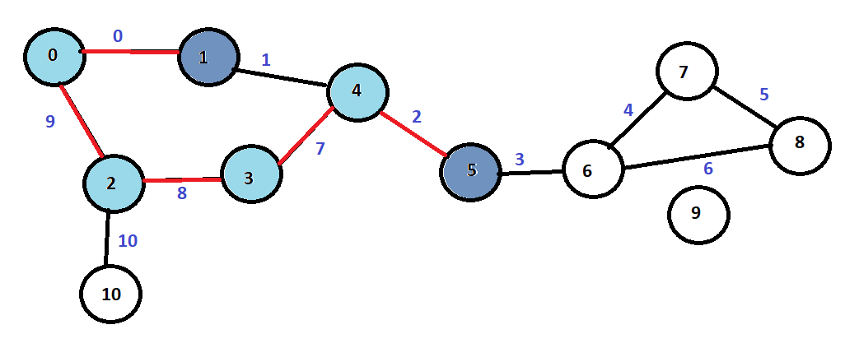

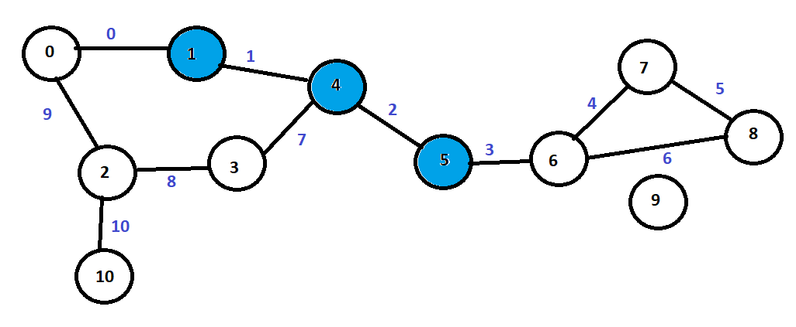
Shortest Path V={5,4,1} E={2,1}

